GHANA TERTIARY EDUCATION COMMISSION (GTEC)
RIGHT TO INFORMATION MANUAL



FEBRUARY,2026

Document Number: GTEC/RTI/2026

Table of Contents
Table of Contents…………………………………………………………………………………..........i
1. Overview 1
2. Directorates and Departments under Ghana Tertiary Education Commission (GTEC) 2
2.1 Description of Activities of each Directorate and Department 3
2.2 GTEC’s Organogram.
2.3 Classes and Types of Information 9
3. Procedure in Applying and Processing Requests 15
3.1 The Application Process 15
3.2 Processing the Application 16
3.3 Response to Applicants 17
4. Amendment of Personal Record 18
4.1 How to apply for an Amendment 18
5. Appendix A: Standard RTI Request Form 21
6. Appendix B: Contact Details of GTECs Information Unit 24
7. Appendix C: Acronyms 25
8. Appendix D: Glossary 26

Overview
This Right to Information (RTI) Manual is under the provisions of the recently passed Act (Act 989) by Parliament and assented to by the former President, Nana Addo Dankwa Akuffo-Addo. The Act gives substance to the constitutional right to information provided under Article 21(1)(f) of the Constitution, enabling citizens to access official information held by government institutions, as well as the qualifications and conditions under which such access may be obtained. Under Section 80, the Act applies to information which came into existence before, or which will come into existence after, the commencement of the Act.

  - Purpose of Manual – To inform the public on the organizational structure, responsibilities, and activities of the Ghana Tertiary Education Commission (GTEC) and provide the types of information and classes of information available at GTEC, including the location and contact details of its Information Officers and units.

Checklist of contents of the Manual:

- A list of Departments under the Institution.
- An organogram and functions of the Institution, and details of the activities of the various divisions or units.
- Classes of Information the institution prepares, has custody of, or is under its control.
- The name, address, and contact details of the Information Officer, as well as the information, including telephone number (s), email, and postal address.
- The arrangements and procedures for amending personal records in the institution.

Directorates and Departments under Ghana Tertiary Education Commission (GTEC)

This section describes the institution’s vision and mission and lists the names of all Directorates and Departments under the institution, including the description of organizational structure, responsibilities, details of activities and classes, and types of information accessible at a fee.
VISION
Driving a world-class Tertiary education system for National Development.

MISSION
GTEC exists to ensure equitable access to relevant world-class education through the formulation and coordination of policies and plans, provision of accreditation, and quality assurance.
- Accreditation Directorate
- Policy Planning and Research Directorate
- Quality Assurance and Compliance Directorate
- Finance Directorate
- Corporate Affairs Directorate
- Administration and HR Directorate

2.1Departments under GTEC
- Credential Evaluation Department
- Special Projects
- Internal Audit Department
- Traditional Universities Department (Accreditation)
- Private Universities Department (Accreditation)
- Technical Universities, Nursing Training Colleges, and Colleges of Education Department.
- Policy Planning Department
- Research, Innovation, and Analytics Department
- Monitoring and Evaluation Department
- Quality Assurance Department
• Compliance Department
- Institutional Support Department
• Accounts Department
- Treasury Department
- Budget Department
- Legal Department
- Publications and Information Management Department
• Public Relations and Protocol Department
- Hospitality Management Services Department
- Human Resource Department
- General Services Department
- Registry Department
- Procurement Department
- IPPD Department
- IT/MIS Department
• Transport Department
• Estates Department
• Stores Department

Responsibilities of the Institution: The Ghana Tertiary Education Commission is responsible for promoting quality tertiary education in Ghana. This includes ensuring high standards in teaching, learning, and research programs, promoting equitable access to tertiary education, and fostering transparent governance and accountability within institutions.

2.1 Description of Activities of each Directorate and Department

Directorate/Department | Responsibilities/Activities
Accreditation | The Accreditation Directorate is responsible for processing applications submitted by tertiary institutions for accreditation. The applications received from institutions typically cover Institutional Authorization, Institutional Registration, Institutional Accreditation, and Program Accreditation. The Accreditation Directorate is also responsible for determining which programs are offered by accredited institutions. This Directorate performs its roles with the support of the Institutional Visits and the Accreditation. Committees of the Board. The following are the Departments under the Accreditation Directorate:  - Traditional University Department  - Private Institutions Department  - Technical Universities and Colleges Department
Policy, Planning and Research Directorate | The Policy, Planning, and Research Directorate is responsible for developing policies and plans, programs, and budgets for all activities of the Commission. This Directorate also coordinates the development of regulations to foster the effective oversight of tertiary education, monitors, evaluates, and assures the compliance of the commission’s programs or projects, through research and data management. The Departments under this Directorate are as follows:  - Policy Planning Department  - Research, innovation, and Analytics Department  - Monitoring and Evaluation Department
Quality Assurance and Compliance Directorate | The Quality Assurance and Compliance Directorate is responsible for Academic Audits, Post Accreditation monitoring and evaluation, and the development of instruments used for the assessment of institutions. The following are the Departments under the Directorate:  - Quality Assurance Department  - Compliance Department  - Institutional Support Department
Finance Directorate | The Finance Directorate is responsible for managing the Board's finances and initiates actions to mobilize financial resources in support of the Board’s operations. The Directorate ensures that appropriate financial controls are instituted to comply with statutory requirements and to ensure the judicious use of financial resources. The Departments under the Finance Directorate include:  - Accounts Department  - Budget Department  - Treasury Department
Corporate Affairs Directorate | The Corporate Affairs Directorate is responsible for Corporate Communications, Public Relations, the Information Resource Centre, Publications, and the Information Management Department and Public Relations and Protocol Department: Publication and Information Management Department: The Department has an Information Centre, which is responsible for the digitization of relevant documents for the Commission. This Centre sources digital journals for storage and retrieval purposes for research and reference.  - Hospitality Management Services Department
Administration Directorate  Credential and Evaluation Department | The Administration Directorate is responsible for the development of policies and procedures for the effective functioning of the Secretariat of the Board. It ensures the availability of adequate resources, both human and material, for the smooth running of the Board’s operations. The main function of the Administration Directorate is General Services, Transport Management, Human Resource Management, Registry, Procurement, Stores, and Front Desk Management.  - Human Resource Department: Registry Department:  - IT/ MIS Department  - Estate Department  - Stores Department  - Transport Department: This unit is responsible for the proper management and provision of an efficient transport system for the Commission.  This Department is mandated to, among other functions, determine the equivalences of Diplomas, Certificates, and other qualifications awarded by Tertiary Institutions in Ghana and elsewhere. The Commission receives applications from individuals, organizations, and institutions across various countries for the evaluation of certificates, diplomas, and other credentials awarded locally and internationally. As part of the evaluation process, certificates and diplomas received are verified by the awarding bodies to establish their authenticity before the levels of equivalence/comparability are established.
Special Projects | This Department supervises the Commission’s unique projects during their lifecycles. The Department develops ideas, conducts research, and ensures the smooth completion of projects at the commission.
Internal Audit Department | The Internal Audit Department provides independent, objective assurance and consulting services designed to add value and improve the Commission’s operations. This Department assists the Commission in accomplishing its objectives by bringing a systematic, disciplined approach to evaluate and improve the effectiveness of risk management, control, and the administrative process at the Commission. It also advises management on how to better execute their responsibilities and duties.

GHANA TERTIARY EDUCATION COMMISSION ORGNANOGRAM

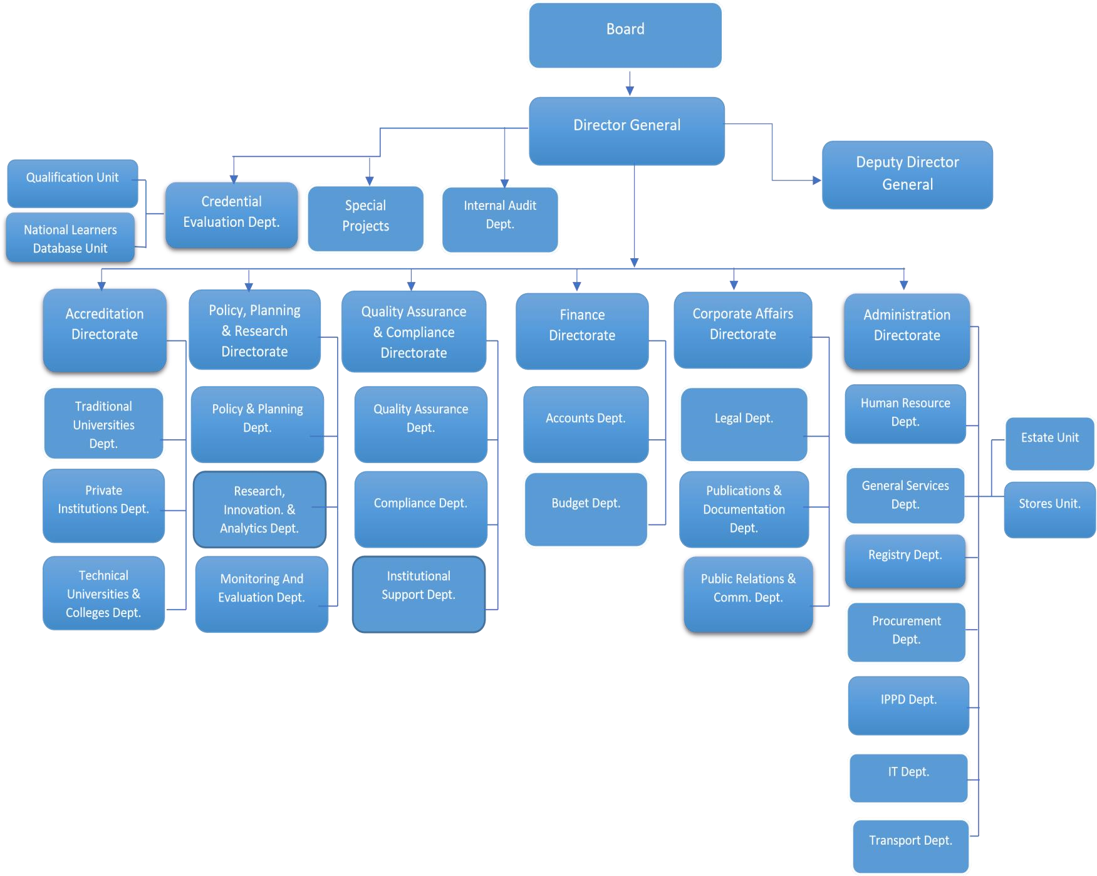

2.3 Classes and Types of Information

List of various classes of information in the custody of the institution:
- Information on tertiary education institutions
- Accreditation of tertiary education institutions
- Accreditation of tertiary education programs
- Evaluation of both local and foreign certificates
- Review of the qualifications, curriculum, or syllabus of tertiary education institutions.
- Presidential charter information
- Administrative information

Procedure in Applying and Processing Requests
Section 18 of the RTI Act provides specific guidelines for application for access to information kept by a public institution. It is thus important that requests for information be made under the provisions of this section. The Information Officer or a designated officer is responsible for dealing with applications made to the Ghana Tertiary Education Commission. To request information under the RTI Act from the Ghana Tertiary Education Commission, applicants are to follow these basic procedures:

3.1 The Application Process
- Application by any person or organization that seeks access to information in the custody of the Ghana Tertiary Education Commission must be made in writing, using the standard RTI Application Form. (See Appendix A for the Standard RTI Application Form.) A copy of the form can be downloaded or completed and submitted electronically on the Ghana Tertiary Education Commission’s official website or the Ministry of Information website.

- In making the request, the following information must be provided:
- Date of the Application.
- Name of the applicant or the person on whose behalf an application is being made.
- Name of the organization represented by the applicant.
- Available contact details of the applicant or address of the person/organization on whose behalf an application is being made (Telephone Number, Email, Postal Address, Fax).
- Brief description of information being sought. (Applicants are to specify the class and type of information, including cover dates.
- Payment of relevant fee if applicable.
- Signature/ thumbprint.

- Provision of identification
The applicant must present at least one (1) of the following valid identification cards (IDs) to serve as proof of identity:
- Driver’s License.
- Passport.
- National ID.
- Voter’s ID.

- The applicant should state the format of information being requested and the mode of transmission. Example (do you need certified true copy, normal photocopy or electronic copies? Would you want to receive it through a postal address, e-mail, courier services, fax, etc.?)

- Where an applicant cannot write due to illiteracy or a disability, he/she may make the request orally. However, oral requests must conform to the following guidelines;
- The Information Officer must reduce the oral request into writing and give a copy of the written request as recorded for the applicant to authenticate. (s. 18) (3).
- The Information Officer shall clearly and correctly read and explain the written request to the understanding of the applicant.2
- A witness must endorse the face of the request with the writing; “the request was read to the applicant in the language the applicant understand and the applicant appeared to have understood the content of the request.”
- The applicant must then make a thumbprint or mark on the request.

3.2 Processing the Application
- Applications would be treated on a priority basis. The Information Officer is responsible for handling requests to ensure that statutory deadlines are met.
- He reviews and identifies which part is exempt based on Section 5 to 16 of the RTI Act and determines which of the units in the institution have the records or are responsible for the subject matter of the request.

- Provision is made under section 20 for the transfer of an application within not more than ten days of receipt where the public institution to which the application was initially made is unable to deal with the application. In such situations, applicants would be notified accordingly with the reasons and dates of transfer.

- For information readily available in official publications, the Information Officer shall direct the applicant to the institution having custody of that publication and notify the public institution of the request. (s.21).

- If a requested information is not readily accessible, the estimated time it will take to search for the information would be communicated to the applicant.

Response to Applicants
- The Information Officer is required under section 23 of the RTI Act to notify applicants within fourteen (14) days from the date of receipt. Applicants should, however, note that the time limit does not apply to applications transferred to another public institution or those that have been refused due to failure to pay the prescribed deposit or fee. (s.23) (6). The notice should state:
- Whether or not full access to the requested information will be granted, or only a part can be given, and the reason.

- The format and mode of access.

- The expected publication or submission day of the information in the case of deferred access.

- The prescribed fee (s.24).

- The Information Officer can request an extension to the deadline if:
- Information requested is voluminous.
- It is necessary to search through a large number of records.
- The information has to be gathered from more than one source.
- Consultation with someone outside the institution is required.

- The Information Officer would, in such situations, notify applicants of an extension as well as the period and reason for the extension. An extension should not be more than seven days.
- In giving applicants access to information, the applicant would be allowed to inspect the information or receive a copy physically or in any other form required, such as electronic, magnetic, optical, or otherwise, including a computer print-out, various computer storage devices, and web portals.
- Where access cannot be given in the form specified by the applicant, access can be given in some other form. In such cases, the applicant shall be provided with a reason why access cannot be given in the specified form.

Amendment of Personal Record
A person given access to information contained in records of a public institution may apply for an amendment of the information if the information represents the personal records of that person and, in the person’s opinion, the information is incorrect, misleading, incomplete, or out of date.

4.1 How to apply for an Amendment
- The application should be in writing, indicating;
- Name and proof of identity.
- Particulars that will enable the records of the public institution to identify the applicant.
- The incorrect, misleading, incomplete, or out-of-date information in the record.
- Signature of the applicant.
- For incomplete information claimed or out-of-date records, the application should be accompanied by
- the relevant information that the applicant considers necessary to complete the records.

- The address to which a notice shall be sent should be indicated.

- The application can then be submitted to the office of the public institution.

- A statutory declaration must be attached.

Fees and Charges for Access to Information
The Act mandates Parliament in Section 75 to approve a fee that public institutions can charge. However, fees shall apply to only the three circumstances stated below:

- Request for information in a language other than the language in which the information is held. (s.75) (3).

- When request is made for a written transcript of the information, the information officer may request a reasonable transcription cost. (s.75) (4).
- Cost of media conversion or reformatting. (s.75) (5).

Under Section 75 (2), fees are not payable for:

- reproduction of personal information
- information in the public interest
- information that should be provided within stipulated time under
the Act
- an applicant who is poor or has a disability
- time spent by the information officer to examine and ensure the
information is not exempt
- preparing the information

Appendix A: Standard RTI Request Form
[Reference No.: ………………………….]

APPLICATION FOR ACCESS TO INFORMATION UNDER THE RIGHT TO INFORMATION ACT, 2019 (ACT 989)

 | Name of Applicant:
2. | Date:
3. | Public Institution:
4. | Date of Birth: |  | DD |  |  | MM |  | YYYY
5. | Type of Applicant: |  | Individual Organization/Institution
6. | Tax Identification Number
7. | If Represented, Name of Person Being Represented:
7 (a). | Capacity of Representative:
8. | Type of Identification: National ID Card Passport Voter’s ID  Driver’s License
8 (a). | Id. No.:
9. | Description of the Information being sought (specify the type and class of information, including cover dates): Kindly fill out multiple applications for multiple requests.:
10. | Manner of Access: |  |  | Inspection of Information  Copy of Information  Viewing / Listen  Written Transcript  Translated (specify language)
10 (a). | Form of Access: |  |  | Hard copy, Electronic copy, Braille
11. | Contact Details: |  |  | Email Address__________________________________  Postal Address_________________________________  Tel: _________________________________________
12. | Applicant’s signature/thumbprint:
13. | Signature of Witness (where applicable)  “This request was read to the applicant in the language the applicant understands and the applicant appeared to have understood the content of the request.”

Appendix B: Contact Details of GTEC’s Information Unit

Name of Information/Designated Officer:
Rabiatu Mateko Azu

Telephone/Mobile number of Information Unit:
0244926962
Email:
Postal Address of the institution:
P.O. BOX MB 28, ACCRA-GHANA,
GA-452-0871

Appendix C: Acronyms
Instructions: Provide a list of acronyms and associated literal translations used within the manual. List the acronyms in alphabetical order using the table below.
Table 1 Acronyms
Acronym | Literal Translation
RTI | Right to Information
MDA | Ministries, Departments and Agencies
s. | section
MMDAs | Metropolitan, Municipal and District Assemblies
<Acronym> | <Literal Translation>
<Acronym> | <Literal Translation>

Appendix D: Glossary
This Glossary presents clear and concise definitions for terms used in this manual that may be unfamiliar to readers, listed in alphabetical order. Definitions for terms are based on section 84 of the RTI Act.
Table 2 Glossary
Term | Definition
Access | Right to Information
Access to information | Right to obtain information from public institutions
Contact details | Information by which an applicant and an Information Officer may be contacted
Court | A court of competent jurisdiction
Designated officer | An officer designated for the purposes of the Act who perform similar role to the Information Officer
Exempt information | Information which falls within any of the exemptions specified in sections 5 to 16 of the Act
Function | Powers and duties
Government | Any authority by which the executive authority of the Republic of Ghana is duly exercised
Information | Information according to the Act includes recorded matter or material regardless of form or medium in the possession or under the control or custody of a public institution, whether or not it was created by the public institution, and in the case of a private body, relates to the performance of a public function.
Information officer | The Information Officer of a public institution or the officer designated to whom an application is made
Public | Used throughout this document to refer to a person who requires and/or has acquired access to information.
Public institution | Includes a private institution or organization that receives public resources or provides a public function
Right to information | The right assigned to access information
Section | Different parts of the RTI Act

